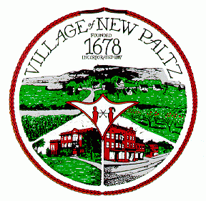

**Village of New Paltz**

**25 Plattekill Avenue**

**New Paltz, NY 12561**

**Office: (845) 255-0130**

**Fax: (845) 255-5103**

**PUBLIC HEARING NOTICE**

Please take notice that the Village of New Paltz Planning Board will hold a Public Hearing on the following application:

**Project Name: PB25-06**

**Applicant: Gary Singleton**

**For: Site Plan- addition to convert a 2 bedroom to a 3 bedroom single family residence**

**Location: 14 Lincoln Place**

**S.B.L: 86.42-4-38**

**Date and Time of Public Hearing: April 15, 2025 at 7:00 PM**

**Location of Public Hearing: Village Hall, 25 Plattekill Avenue, New Paltz**

|  |
| --- |
| Join the Public Hearing via Zoom:  <https://us06web.zoom.us/j/83275511882?pwd=bTjEAGQmb1mdC1jVQDPksiQqGlVaZa.1>  +1 646 558 8656 | Meeting ID: 832 7551 1882 | Passcode: 875048 |

Information regarding this application may be found on the Village website here: <https://www.villageofnewpaltz.org/planning-board/>

The Planning Board will hear all persons in support of such matter or any objections thereto during the Public Hearing at 25 Plattekill

Avenue in order of appearance on the Agenda. Written comments must be received before 4:00 PM on the date of the above hearing and be

submitted by e-mail to planningzoning@villageofnewpaltz.org, or at the address listed above. All reasonable accommodations will be made for persons with disabilities. In such a case, please notify Planning and Zoning in advance so that arrangements can be made.